Master Document — Team Page Mock Sprint
Worked example — Team Byte Size
The git urls are fake – this is just an example

[Login Restyling Bootstrap] Task 1 —Write Requirements: Team Page & Login Styling
Role | BA — Nhi | Date | Monday, 3 August 2026
Completion comment
Done: Documented required fields for the team page (team name, project name, per-member photo/name/role, about-us blurb) and confirmed login work is styling-only, no auth logic changes.
Deliverable: Requirements document, committed to the team repo.
Note for next role: UX — we have 5 team members, one doesn't have a headshot yet, so the design needs a placeholder-avatar treatment. Two members also have longer blurbs, so don't assume a one-line blurb.
Git URL: https://github.com/team-byte-size/team-page/blob/main/docs/requirements.md

[Login Restyling Bootstrap] Task 2 — Design Login Style & Team Page Layout
Role | UX — Sam Okafor | Date | Tuesday, 4 August 2026
Completion comment
Done: Produced mockups for the restyled login page and the team page layout, including the placeholder-avatar and long-blurb cases BA flagged.
Deliverable: Figma file, linked from the team repo.
Note for next role: BA — the long-blurb case is handled with a "read more" expand rather than truncation. Please confirm that's acceptable before you approve.

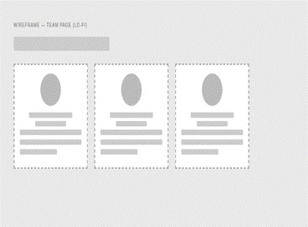

[Login Restyling Bootstrap] Task 3 — Validate Design Against Requirements
Role | BA — Jordan Patel | Date | Tuesday, 4 August 2026
Completion comment
Done: Checked both mockups against the requirements doc. All fields present, login scope stayed to styling only, placeholder-avatar and long-blurb cases both covered. Approved as-is, no changes requested.
Deliverable: Design validation sign-off, committed to the team repo.
Note for next role: Dev — you're clear to build exactly to the Figma file, no open questions from BA's side.
Git URL: https://github.com/team-byte-size/team-page/blob/main/docs/design-validation.md

[Login Restyling Bootstrap] Task 4 — Style Login Page
Role | Dev 1 — Riley Chen | Date | Wednesday, 5 August 2026
Completion comment
Done: Applied the approved login styling (colors, layout, branding). Confirmed auth logic, validation, and session handling are all untouched.
Deliverable: Branch/commit with the styling changes.
Note for next role: Nothing blocking — moving straight on to the team page build myself.
Git URL (commit): https://github.com/team-byte-size/team-page/commit/4a1c9e2

REAL OUTPUT — rendered login page
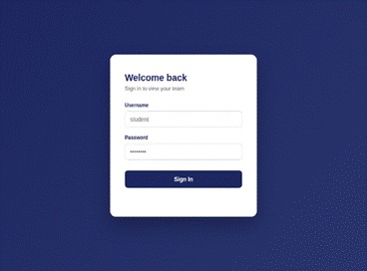

[Login Restyling Bootstrap] Task 5 — Build Team Page & Auth Redirect
Role | Dev 1 — Darcy | Date | 2026-08-13
Completion comment
Done: Team page built per the design (name, member cards with photo/role, about-us blurb with expand-on-long-text). Login now redirects here on success; team page redirects back to login if accessed directly without a session.
Deliverable: Branch/commit with the team page and route guard.
Note for next role: Dev 2 — please test against the deployed URL once it's live, not localhost.
Git URL (PR): https://github.com/Alex-D-4089452/garage-basic-22-nbn/pull/13
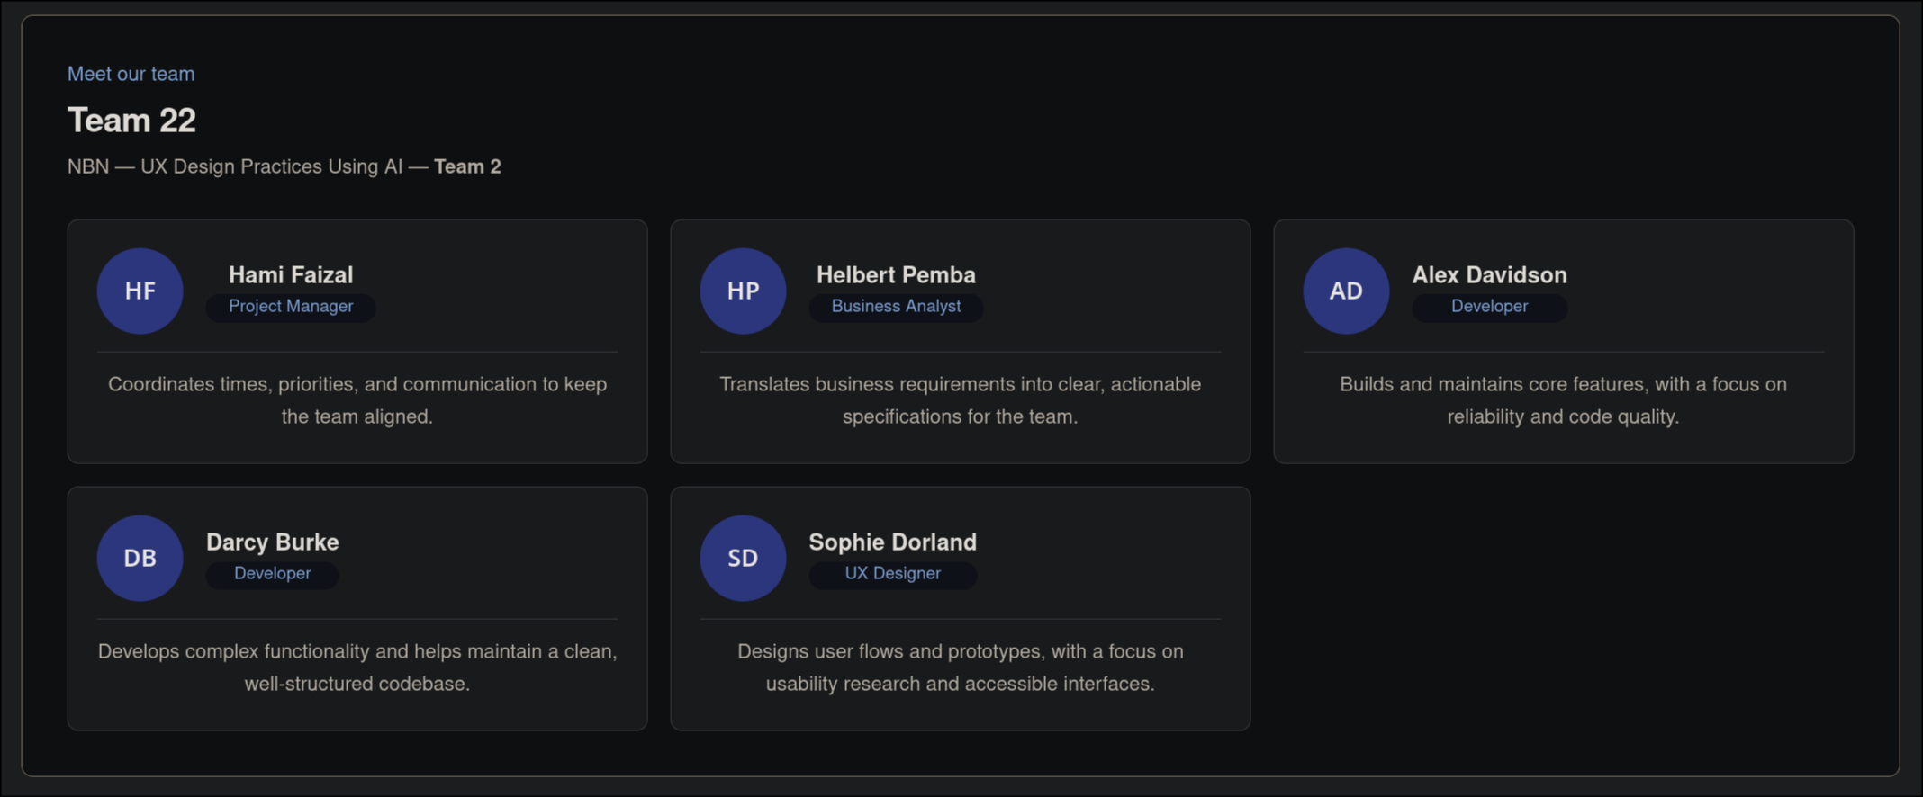

[Login Restyling Bootstrap] Task 6 — Test Login → Redirect → Team Page Flow
Role | Dev 2 — Morgan Tran | Date | Thursday, 6 August 2026
Completion comment
Done: Tested the full happy path on the deployed URL — valid login, redirect fires, all member cards render correctly with photo/role/blurb, expand-on-long-text works.
Deliverable: Test script and test report.
Note for next role: No issues found on the happy path. Moving on to edge cases next.
Git URL (test script): https://github.com/team-byte-size/team-page/blob/main/tests/flow.spec.js
Git URL (test report): https://github.com/team-byte-size/team-page/blob/main/docs/test-report-flow.md

[Login Restyling Bootstrap] Task 7 — Test Edge Cases & Log Bugs
Role | Dev 2 — Morgan Tran | Date | Thursday, 6 August 2026
Completion comment
Done: Tested invalid login, direct team-page URL access without login, missing-photo member, and an unusually long blurb. No bugs found.
Deliverable: Edge case test report.
Note for next role: PM — everything passed, nothing outstanding for Dev 1 to fix before your review.
Git URL (test script): https://github.com/team-byte-size/team-page/blob/main/tests/edge.spec.js
[ IMAGE PLACEHOLDER — Invalid login error state screenshot — replace with actual screenshot ]

[Login Restyling Bootstrap] Task 8 — Final Review & Sign-Off
Role | PM — Alex Lin | Date | Friday, 7 August 2026
Completion comment
Done: Reviewed the feature end-to-end against the requirements and design. Verified every prior task's checklist and completion comment. Everything matches — approved.
Deliverable: Sign-off note.
Note for next role: None — feature complete, board closed out.
Git URL: https://github.com/team-byte-size/team-page/blob/main/docs/signoff.md

[Login Restyling Bootstrap] Task 9 — Deploy
Role | DEV – Alex Davidson | Date | Saturday 8, August 2026
Completion comment
Done: Documented required fields for the team page (team name, project name, per-member photo/name/role, about-us blurb) and confirmed login work is styling-only, no auth logic changes. Deployment completed via boilerplate pipeline. Live URL loads without errors.
Deliverable: Deployed URL: https://garage-basic-22-nbn.vercel.app/
Note for next role: Devs – add team page.

